The Problem with Pokémon & Pokémon GO

Pokémon GO player walking on car hoods!

The Problem with Pokémon & Pokémon GO
David L. Brown, Ph.D.
© 09-1999 & 07-2016

Here We Go Again with Pokémon GO

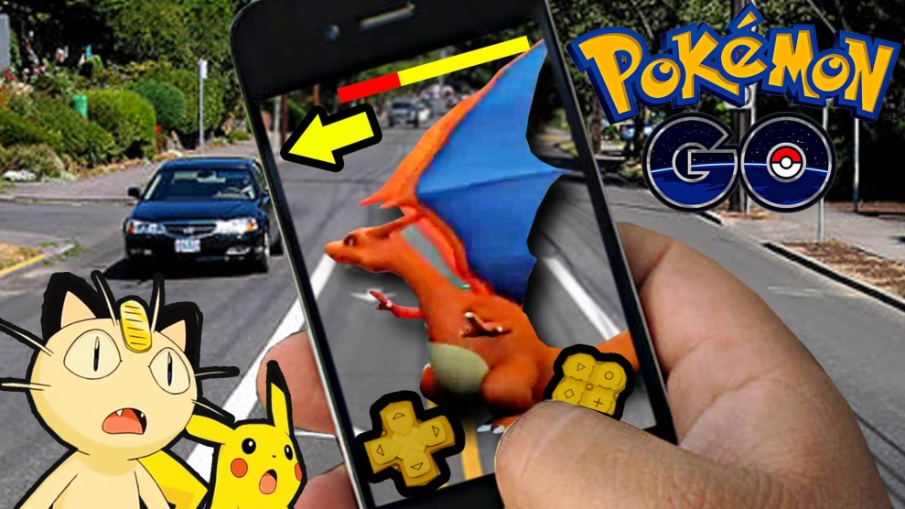

In early July, 2016, Pokémon GO exploded onto the USA market! I left the church at 9:45 p.m. Saturday evening, after studying for my Sunday morning sermon. As I rode out on my Goldwing, I encounter at least 20 mostly teens, but a few adults crawling in our bushes, wandering over the grass and walking in our flower beds. I stopped the kids and said, “Hi. What in the world are you doing?” Their response was “this is a PokeStop and we are looking for Pokémon…and they are all over here”.

This was my introduction to the Augmented Reality game, Pokémon GO. I had written about Pokémon card games, cartoons and video games way back in 1999. I had thought they had faded into obscurity. However, new life has been breathed into the old game; it has smashed all the records, surpassing Candy Crush to become the biggest US mobile game of all time.

It is all good right? NO!!! There are DANGERS with Pokémon and Pokémon GO you should know about…

- First, there are PHYSICAL DANGERS.
- Second, there are LEGAL DANGERS.
- Third, there are PSYCHOLOGICAL DANGERS.
- Fourth, there are SPIRITUAL DANGERS.

We will examine these and other things in this booklet.

How Do You Determine What Is Right &

What Is Not Right?

What is your worldview? A worldview is the framework of ideas and beliefs through which an individual or group views reality and interacts with the world around him. A personal worldview is a combination of all you believe to be true, and what you believe becomes the driving force behind every emotion, decision and action.

When you sift it all down there are basically two world views; A Biblical or Christian World View and A Satanic World View.

What is a Biblical World View? A biblical worldview is based on the infallible Word of God. When you believe the Bible is true, then you allow it to be the foundation of everything you say and do. You seek to pattern your character after biblical character traits. A person who has a biblical world view follows the 3 biblically approved ways to seek wisdom and power. 1) Prayer - James 1:5 2) The Bible - 2 Tim. 3:16-17 3) Wise counsel from godly people - Prov. 15:22; Psa. 1:1.

What is a Satanic World View? The Devil is called “the God of this world” in 2 Corinthians 4:4. Those who have this world view do NOT seek wisdom from above. Their wisdom is a corrupt wisdom which is earthly (it leaves the God of the Bible out), sensual (appeals to our base, sinful desires) and devilish (demonic) James 3:15. In the Pokémon games, aspects of an occult belief system are present, biblical character traits are not evident, the philosophy that is promoted is contrary to the Bible and the power of the Pokémon is occult power.

Here is the problem. Most people who would say they have a Biblical/Christian Worldview do not even know what that involves. The Barna Research Group did a nationwide survey and determined that only 4% of Americans really has a “biblical” worldview. Barna said, "Although most people own a Bible and know some of its content, our research found that most Americans have little idea how to integrate core biblical principles to form a unified and meaningful response to the challenges and opportunities of life.”

Here is a list of questions that will assist you in determining if what you want to do is compatible with a Biblical/Christian Worldview.

What belief system or doctrine(s) are evident or being advocated? Is it Christian belief system or is it contrary to the teachings of the Bible. If contrary to the Bible, it must be rejected. (1 Tim 4:1).

What philosophies and values are evident or being advocated? Humanism, hedonism, Evolution, etc. (Col. 2:3)

What is the origin of the power that energizes? Is it the triune God of the Bible or from another source? (Psalm 62:11)

Are there psychic, occult, satanic, New Age symbols incorporated? (Eph. 5:11)

Are your thoughts, imaginations steered in a wholesome or unwholesome direction? (Proverbs 6:18; 2 Cor. 10:5; Prov. 4:23)

Does it glorify violence or evil? (Psa. 11:5; Rom. 12:9)

Does it depict immorality and arouse lustful desires? (Psa. 101:3)

Does it draw you closer to God and build Godly Character? (Psa.1)

Allow me to sum it up with one short verse - 1 Corinthians 10:31 “Whether therefore ye eat, or drink, or whatsoever ye do, do all to the glory of God.”

My intention is to draw your attention to the biblical problems with the old game that has been given new life with the arrival of Pokémon GO.

Pokémon GO becomes global craze as game overtakes Twitter for US users! In fact, it is the BIGGEST mobile game in US History and it might come as a surprise to you that the main players are 25 to 34 year olds, though there are a multitude of young players as well. Pokémon GO moves into the age of augmented reality using an app on your smartphone.

What is augmented reality? It is a technology that superimposes a computer-generated image on a user’s view of the real world, thus providing a composite view. In Pokémon GO it uses your smart phone camera to show you the real world and then superimposes a Pokémon character on the screen. Below is an example. You see Arlington Cemetery with Bellsprout superimposed. A sign, 20 feet away advises visitors that Arlington National Cemetery is “hallowed grounds” and “our nation’s shrine” and as such, people are to conduct themselves with “dignity at all times.”

They are having the same problem with Pokémon players at the Holocaust Memorial. In a statement, communications director for the Holocaust museum Andrew Hollinger said playing the game inside a memorial to victims of the Nazi regime was "extremely inappropriate".

A cemetery and a Holocaust Memorial are a place to show respect for the dead! It is NOT an appropriate place to run around laughing, running over graves hunting for Pokémon characters!

An article in the online edition of the July 12, 2016 theguardian fills us in on some of the details. Pokémon GO takes “gamers out of the living room and on to the streets as they compete to capture, train and battle Pokémon characters using their mobile phones.” The goal is the same as the card game and video game; players battle and capture the “pocket monsters” in a quest to become the greatest Pokémon trainers. However, unlike the earlier video and card games, “players move around the real world looking for Pokémon to capture.” Quoting the article again - “When the app is opened, it shows a map of the area around the player, with various points of interest marked – statues, clock towers and so on.” Players must physically walk up to one of the points, referred to in the game as a Pokéstop, then tap an icon on screen and you are rewarded with items and experience points. In addition, a Pokémon creature can appear anywhere at any time. If you have been led to a church, a creature may appear in clerical garb. If you are near a graveyard, a ghostly Pokémon may appear, etc. If you see the creature and tap on it, a mini game starts, and of course the goal is to catch the Pokémon.

The History of Pokémon
With the REVIVAL of this occult game, I want to share with you the original research I did when the game first hit the market. The name Pokémon is derived from pocket monster. Pokémon has entertained Japanese youth since 1995. While it is rare for a Japanese cultural phenomena to be duplicated in the Western world, Pokémon has proved to be the exception. Pokémon has moved into the United States "BIG TIME" and captured the minds of elementary aged children all over this country. Pokémon is everywhere…Nintendo video games, cartoon shows on television, a movie, comic books, toys, clothing, VHS videos, DVD's, and the wildly popular collector card game. The Pokémon "virus" has infected virtually every media outlet imaginable, and by plan, the "virus" has become an epidemic among elementary aged children causing them to crave and beg for more Pokémon paraphernalia. Countless elementary aged children are obsessed with Pokémon.
Measuring Pokémon by the Bible

Without apology, I acknowledge that I am writing this pamphlet from a biblical perspective. And, I believe there is a battle going on for the minds of our children and grandchildren. In fact, Satan and his diabolical hordes want to corrupt the minds of children and adults as well! One of the problems is that Satan is getting the upper hand because Christians are oblivious to the tactics the adversary is using to pollute the minds of men, women, boys and girls. While many Christian adults would catch blatant demonic doctrines, the truth is, Satan seldom mounts a direct assault. Rather, he, through his human helpers, uses subtle, clandestine and deceptive methods to advance his evil doctrines. So, how can we detect these deceptive methods and evil doctrines? How can we protect our children and ourselves? The Bible says, "Prove all things; hold fast that which is good." 1 Thessalonians 5:21. The Bible says, "Whatsoever ye do, do all to the glory of God" 1 Corinthians 10:31. The Bible says, "…Abhor that which is evil; cleave to that which is good." Romans 12:9. Therefore, we must measure Pokémon paraphernalia by the principles of the Bible to determine if it is acceptable. I will set out the facts.

- What values, beliefs, and philosophies does the game promote?

From 1998 to 2003 Wizards of the Coast translated from Japanese and distributed Pokémon Trading Cards. Here is an exact quote right from the Web page of the producer - "The Pokémon Trading Card Game is a new collectable Card Game that is made and distributed by Wizards of the Coast. The same company that made the best-selling game ... Magic: The Gathering." Magic: The Gathering is a heavily occult laced trading card game very popular in the 1990's. I have a research report titled Beware of Magic: The Gathering that can be viewed on the Logos Web page at - http://logosresourcepages.org/magic-g.htm
Oh yes, I should mention that Wizards of the Coast also owns TSR, the producers of all the Dungeons & Dragons materials. When I discovered who owned the American Pokémon Trading Card Game rights, I knew the game was not just an innocent card game for elementary school children. However on October 1, 2003, Wizards of the Coast's license to translate and distribute Pokémon Trading Card Game was transferred to The Pokémon Company International by Nintendo.

The Origin of the Pokémon Characters

What is the origin of the Pokémon characters? The characters are based on Japanese occult mythological Kami characters. The creatures inhabit trees, rivers, and rocks, similar to the ancient Greeks, Norse or Celtic myths that described a world teeming with fairies and elves. Here is the technical definition of Kami -

Kami (Japanese: 神 ?) [káꜜmì]) are the spirits or phenomena that are worshipped in the religion of Shinto. They are elements in nature, animals, creationary forces in the universe, as well as spirits of the revered deceased.

For more on Shintoism see - (www.gotquestions.org/Shintoism.html).

“When you take the ancient myths that gave us fantastic animals such as centaurs and unicorns and place them within the animistic worldview of Shintoism, you start to see why the Eastern world of Pokémon feels both strange and familiar.” Clearly, Pokémon does NOT reflect a Biblical World View! It is rooted in the occult teaching of Shintoism.
(https://blogs.thegospelcoalition.org/trevinwax/2016/07/13/pokemon-go-in-a-fractured-and-flattened-world)

If that is not alarming enough for you, allow me to share with you the testimony of a missionary working in the Amazon region with the Yanomamö tribe. Bautista was an ex-witchdoctor. He accepted the gospel of Jesus Christ.

The missionary got a letter from one of his supporting churches saying that there was a discussion going on in church and the church was divided about Pokémon. A book was sent with all the Pokémon characters asking if the missionary would have Bautista look at it and see what he thought about the characters. One day Bautista came by the missionary’s house. Here is the account in the missionar’s own words…

Keila remembered the book and ran upstairs to get it. She handed the book to me. Opening the book at random, showing him a picture I asked. “What do you think of this?” He looked at it, and said, “Oh, I know this one.” He suddenly had my attention!

He went on, “Oh, this is a nasty little demon. It is always underfoot, bites, scratches, screeches and what not.” I looked at the page, and on the list of attributes, it said, “bites, scratches, screeches, claws…” and I forget what else, but it was as if Bautista was reading the page, and he does not read or speak one word of English. So he made a believer out of me. I figured that the first one could have been just a lucky guess, so I flipped the page to another picture and asked him about that one, again, he told me exactly what its attributes were. He did that over and over. There were some he did not recognize, and he said. “There are so many demons, it is impossible for any one person to know them all.”

You can read the entire article at -
http://amazonaswayamou.com/2011/09/spiritual-insight/

If you had any doubt about which worldview Pokémon promotes, this should make up your mind for you.

Some of the Characters

Next, I looked into a few of characters in the Pokémon video games, comics, cartoons, movies, and now Pokémon GO. What kind of values do they have? Ash Ketchum (a boy) is one of the main characters. He is described as "an energetic and determined 10-year-old…a little too competitive." He is obsessed with catching all Pokémon and driven "to become the world's foremost Pokémon Master." Oh yes, you can be sure that the Pokémon Rap song and mantra will be included in the materials -

"I will travel across the land
Searching far and wide.
Each Pokmon to understand
The power that's inside.
Gotta catch them all!"

The last line of the Pokémon mantra, "Gotta catch them all!" is used over and over again in Pokémon paraphernalia because it fuels the craving for more cards, games, toys, gadgets, and comic books.

Look at another character, Ash's companion Misty. She is described as "headstrong and stubborn, constantly quibbling with Ash…and seems to harbor deeper feelings for Ash."

Then there is the third member of the trio Brock who is "by far the most hormonal. Brock's fascination with the opposite sex many times gets him or the group into trouble, although he's yet to have anything resembling a score."

Now take a look at Pokémon trainer Gary. He is "a real jerk…self-centered, vindictive and obnoxious. Then there are Jessie & James. Here is how they are described – "Prepare for trouble, make it double.... Jessie, James…are a mysterious and evil gang looking to steal rare Pokémon. Jessie and James are stuck up, fashion conscious, and prone to cross-dressing."

Headstrong, stubborn, quibbling, self-centered, vindictive, obnoxious, hormonal, sexually preoccupied, evil, thieving, cross-dressing jerks are most definitely not biblical role models! These characters do not portray biblical values. Pokémon does not measure up!
- Are supernatural powers portrayed, and if so, what is the source or origin of those powers? Are occult, New Age characteristics or symbols included?

Pokémon has supernatural powers. There are telekinetic powers used by some of the characters. Telekinesis is the occult power to move objects at some distance by nonphysical, spiritual (occult) means. Further “Some Pokémon grow, or evolve.” This is facilitated by the “Energy cards” that “make your Pokémon bigger and more powerful.” And what is the source of this power? It is the pantheistic power of the occult, not the supernatural power of God. I have found two cards that make this very clear (there are likely more). They are Abra and Kadabra. Yes, these are their actual names. "Abrakadabra" (or abracadabra) has been a word long associated with occult magic. Webster's dictionary defines it this way - 1) a word supposed to have magic powers and hence used in incantations, on amulets, etc. 2) a magic spell or formula. It is no accident that the two Pokémon called Abra and Kadabra are psychic cards with magical powers.
On the Abra card we read "Using its ability to read minds, it will identify impending danger and teleport to safety." Then there are the occult symbols on Kadabra. He has a pentagram on his forehead, SSS on his chest and he is giving the Satanic salute with his left hand. All of the above have strong occult significance. It is clear from the Bible (Deuteronomy 18:10-12) that we are neither to participate in nor associate with activities related to the occult.
Some of the readers will no doubt protest, "it's only a game!" To be sure it is a game, but a game that does not glorify God! When God says something is wrong, it is wrong regardless of what form it is in. Not only that, but many of the kids who play this game are seduced into believing the principles that the game subtly teaches. Here is but one example. In the booklet that comes with Pokémon, note what is stated – "Welcome to the world of Pokémon, a special place where people just like you train to become the number-one Pokémon Master in the World! But what is a Pokémon, you ask. Pokémon are incredible creatures that share the world with humans,” says Professor Oak, the leading authority on these monsters. There are currently 150 documented species of Pokémon (this was in 1999). In 2016 there are 729. You can see the list at - https://en.wikipedia.org/wiki/List_of_Pok%C3%A9mon.

Each Pokémon has its own special fighting abilities. . . . Some grow, or evolve, into even more powerful creatures…. “Carry your Pokémon with you, and you're ready for anything! You've got the power in your hands, so use it!"

Listen, kids are carrying around their Pokémon like a magic talisman. Author and researcher Berit Kjos tells of a mom who overheard two boys discussing their little pocket monsters. As the conversation developed one boy said, "I'll just use my psychic powers." It was clear that the so called fantasy world of Pokémon had already conditioned these boys’ thinking to be receptive to a key occult doctrine - psychic powers!
Pokémon promotes occult values, not biblical values and therefore should be rejected!
- Where are the player's thoughts and imagination being directed?

I pointed out earlier that Pokémon originated in Japan. What I did not draw to your attention was that a Pokémon Master is a spin-off of a martial arts master in Japan. Pokémon Masters are the leaders of fighting schools or battling gangs that solve their problems by beating their opponents. And how do they do this? Their little booklet says, "Some attacks cause the Defending Pokémon to be Asleep, Confused, Paralyzed, or Poisoned."
The Bible warns us to be cautious about what we occupy our minds with (Proverbs 4:23). The games a child plays, the television programs he watches, and the things that he listens to have a powerful mind shaping influence over that child. Mental health professionals are finally coming to understand what the Bible has said all along – the things you let into your mind shape your thinking and your thinking directs your actions. This truth was acted out at the Columbine High School slaughter. The shooters had saturated their minds with violent video games, Gothic death music, and violent reading material. The result was on April 20, 1999, twelve students and one teacher were murdered.
Could Pokémon influence the children who play it? I pray that it does not happen, but I wonder how long it will be before a grade school child, tries to do what is written on the Weepingbell - Razor Leaf Pokémon card. It says, "It spits out poison powder to immobilize the enemy, and then finishes the enemy with a spray of acid." Does this line up with what the Bible has to say about how to handle our enemies in Romans 12:14-22? I think not! It is clear that Pokémon leads the player's imagination down the wrong path. The Bible says that we are to abhor that which is evil, and cleave to that which is good (Romans 12:9). Poisoning, paralyzing, etc. your enemies is clearly evil and no one should occupy their minds with such thoughts – game or no game. Our every thought is to be screened to be sure Christ approves of it (2 Corinthians 10:4-5). If it does not line up, it is to be rejected.
THE PROBLEM WITH Pokémon & Pokémon GO
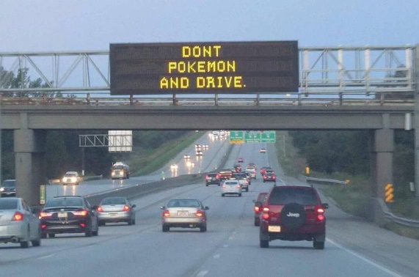
- First, there are PHYSICAL DANGERS.

85% of the adults who play Pokémon GO play it while driving. Recently one man drove into the back of a Baltimore Police car while playing. Two men fell off a cliff in California while playing. A player was hit by a car in Bangor, Maine. Players have been robbed at gunpoint. Child molesters are using the game to attract children they can molest. A teen was killed in an ambush as he hunted for the virtual characters. There are physical dangers when you play Pokémon GO.

- Second, there are LEGAL DANGERS.

This is an article titled ‘Pokémon Go’ Prompts Numerous Warnings From Law Enforcement Agencies by Tracy Bloom and Christina Pascucci -

Activities related to "Pokemon Go" have prompted law enforcement agencies around the U.S. to issue a number of warnings about the increasingly popular smartphone game.

Some agencies have noted a rise in trespassing and other suspicious activities because of the augmented reality app, which has been downloaded on more than 1 million Apple and Android devices since its release Thursday, CNN reported.

The Goochland County Sheriff's Office in Virginia noted that deputies have located a number of people going to businesses, churches and government buildings when they are closed to look for Pokemon characters.

Those actions are considered trespassing, the department said, and potentially puts the individual at risk.

The Wyoming, Minnesota, Police Department issued a similar warning about trespassing on private property while playing the game.

"Please don't try it out at 1 AM and walk into someone's backyard to catch one. Please. Pretty please. #PokemonGo," the department tweeted.

- Third, there are PSYCHOLOGICAL DANGERS.

Dr. Manny Alvarez is chairman of the department of obstetrics/gynecology and reproductive science at Hackensack University Medical Center in New Jersey. He is concerned that spending so much time playing this and other video games alters children’s’ behavior, disrupts their sleep patterns and contributes to a lack of social skills. He goes on to say this -
When I say that I am “afraid” of Pokemon, I am not referencing the little cartoon characters who blow fire and ice, I am talking about the trend of creating artificial realities for people to live in. We face many challenges in our current world with serious issues that won’t be fixed unless we’re a part of the solution. That being said, we should not be “Poke-ing” around in a virtual world where we spend half of our days chasing shadows that are not actually there.

- Fourth, there are SPIRITUAL DANGERS.

Clearly Pokémon & Pokémon GO DO NOT Promote A Biblical/Christian World View. I have documented its association with the occult. Further, its subtle suggestions, images and values are manipulating the minds and feelings of the children who are into it. Pokémon conditions them to accept humanistic wisdom and occult spirituality. Heavy involvement in Pokémon blurs the player's ability to distinguish between fantasy and reality and sears the conscience of the player as well, deadening his or her interest in biblical spirituality.

God wants his children to have a completely different focus. We are even told where our thoughts should be directed in Philippians 4:8 "Finally, brethren, whatsoever things are true, whatsoever things are honest, whatsoever things are just, whatsoever things are pure, whatsoever things are lovely, whatsoever things are of good report; if there be any virtue, and if there be any praise, think on these things.”

God wants us to use our time wisely! Researchers tell us that Pokémon GO players spend from 2 to 5 hours a day playing the game. Consider what Ephesians 5:15-16 says, “See then that ye walk circumspectly, not as fools, but as wise, 16 Redeeming the time, because the days are evil.”

Pokémon and Pokémon GO do not measure up! I suggest the best place for Pokémon paraphernalia is in the trash can and delete the app from your phone.
Available from: Dr. David L Brown, P.O. BOX 173, Oak Creek, WI 53154 - Email:PastorDavidLBrown@gmail.com

